RESUME
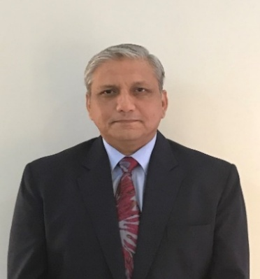
- Contact Information
- Name: BRIG IFTIKHAR HAIDER, RETD
- Phone: 00923212245557
- E Mail: alamgirian66@hotmail.com
- Address: H.No 29, Lane 1, Zone 1, Garden City Bahria Phase 7, Islamabad
- CNIC No: 37405-2093198-5
- DOB: 29 Jan 1966

- Statement I have more than three decades of experience in the Army, having served in numerous roles of command, staff, training, and logistics support. Likewise, post-retirement job has expanded my knowledge of security and housing development. Likewise, my interest in the field of Education Planning also affords diversity to my usefulness in society. It gives me confidence that I can contribute totally and completely to the best of my abilities.
- Career Summary
- Logistical Operations Vast experience of planning and execution logistical support at different levels of Army both during peace and war like situations.
- Disaster Relief Operations. Management and planning of relief operations for earth quake and flood affected areas.
- Protocol and Coordination. Protocol duty with high ranking military and civilian dignitaries at Islamabad and Karachi. Coordinating meetings and visitors for VVIPs at GHQ and Karachi.
- Command, Training and Security. Command of large logistic units, training of freshly inducted manpower and control of a medium size garrison.
- Transport Fleet Management. Logistical management of a large transport fleet including supply of POL and technical maintenance.
- International Experience. Participation in Gulf War 1. Service with UN at South Sudan including daily interaction with local and international staff and media persons.

- Educational Background
- Military College Jhelum – Matric
- Sir Syed College Rawalpindi – FSc
- BA fro Peshawar University, History and Economics
- C&SC Quetta / Balochistan University – BSc (Hons) in Leadership & War Studies
- AIOU – PGD Education Planning Management
- Other Certifications/Qualifications
- Member of Institute of Logistics and Transportation (UK), M -1241
- Certified Courses while serving in UN:-
- Operational Logistics Support
- Security Measures for United Nations Peace Keeping
- Conduct of Humanitarian Relief Operations
- Ethics in Peace Keeping
- United Nations Police – Restoring Order following Hostilities
- Peace Keeping and International Conflict Resolution
- International Humanitarian Law and Law of Armed Conflict
- Aerial Delivery Course ; parachute packing, aerial drop and jumping.
- Short duration training at Mercedes Germany on High End Bullet Proof Cars

- Strong Points
- Management.
- Leadership, Man Management and Capacity to Work.
- Fluency in English, Urdu both verbal and written. Arabic (reading with partial understanding)
- Human Resource Management
- Workshop management and Computer Handling
- Staff work and office management
- Administration
- Understanding of Protocol duty with VVIPs (dignitaries both local / foreign)
- Other Interests
- Hiking / Trekking
- Golf
- Reading

- Additional Information
- Marital Status: Married since 1995
- Children: Two sons

