BEENISH AKHTAR  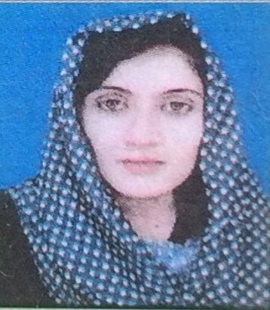  House #128 St#5 east Shabirlane Peshawar road Rawalpindi  CELL:0332-0411732  EMAIL:beenishmajidbloch@gmail.com |  | - Diploma in Computer Application (TEVTA)  - Four Year Teaching experience in Johar Public High School (BHAKKAR)  - Microsoft Office  - Typing Speed 30WPM  Abdur Rahim Khan Ex.DCS in PAEC contact: 03009769890
  DOB – 17/2/1989
  Domicile : BHAKKAR
  LANGUAGES
  ENGLISH
  URDU
  ACTIVITIES
  Reading Books
  Cooking
  Dress Designing
  OBJECTIVE
  Seeking a career opportunity in a progressive organization which ensures opportunities for professional growth.
  EDUCATION
  MSC (Economics)
  University of Sargodha Pakistan
  B.Ed (Allama Iqbal Open University)
  Bachelor of Arts (Economics, Education, Health & Physical Education)
  University of Sargodha Pakistan
  Intermediate (F.A) (Economics, Education, Health & Physical Education
  Board of intermediate & secondary education Sargodha.
  Secondary School Certificate (Matric) in Science
  Board of intermediate & secondary education Sargodha.
  PROFESSIONAL AND TECHNICAL EDUCATION
  COMPUTER SKILL
  REFRENCES

