Ambreen Naz
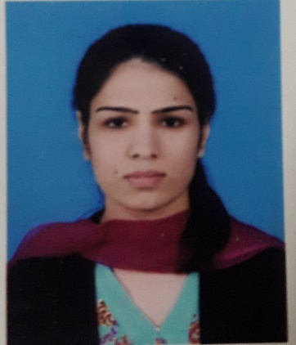
Contact Information:
Postal Address: St#4, House#1, Yousaf Colony Near Danyal Plaza Scheme 3,
Rawalpindi, Pakistan

Ambreennaz066@gmail.com
+923349643864

Academic and Administrative Coordinator,

The Department of Physics and Electronic Engineering,

Fatima Jinnah Women University,

Rawalpindi, Pakistan.

Visiting Lecturer,
Arid Agriculture University, Rawalpindi, Pakistan.

Visiting Lecturer,

NUST Business School

National University of Sciences & Technology
Visiting Lecturer,

JSPPL, NUST

National University of Sciences & Technology
Visiting Lecturer,

Fatima Jinnah Women University
Rawalpindi

Academic Assistant
Dawn Public School
Wah Cantt

Degrees:
(2018) M.Phil. International Relations, Preston University, Islamabad, Pakistan
(2013) MA, Defense and Diplomatic Studies, Fatima Jinnah Women University, Rawalpindi, Pakistan
(2009) BA, Government Viqar-un-Nisa Post Graduate College for Women, Rawalpindi, Pakistan
(2007) FA, Government Viqar-un-Nisa Post Graduate College for Women, Rawalpindi, Pakistan
(2004) Matric, Federal Government school no 6, Islamabad, Pakistan

University Teaching Experience:
Visiting Lecturer,
Arid Agriculture University, Rawalpindi, Pakistan
Courses Taught in Departments:
Department of Computer Science
Department of Management Science
Department of Human nutrition and Dietetics

Courses Taught:
International Relations
Pakistan Studies

Visiting Lecturer,

NUST Business School &JSPPL Courses Taught in Departments

National University of Sciences & Technology NUST Business School &JSPPL
Courses Taught:
Ideology and constitution of Pakistan

Visiting Lecturer,

Fatima Jinnah Women University Courses Taught in Departments

Physics, Economics,
Courses Taught:
Ideology and constitution of Pakistan

School Administrative Experience:
Departments Served In:
Administration
Administrative Assistant,
Dawn Public School,
Wah cantt, Pakistan

University Administrative Experience:
Departments Served In:
Vice Chancellor Office
Admissions Department
Quality Enhancement Cell
Dean Office
Department of Physics
Department of Electronic engineering

Academic and Administrative Coordinator,
Fatima Jinnah Women University,
Rawalpindi, Pakistan

Research and Publications:

Journal Articles:

Malik. S., Naz. A., Asghar. F., Haq, A., Fatima, H., and Malik. Z.A. (2022) “Pakistan-Afghan Relations: A Critical Assessment,” International Journal of Special Education,37 (3): 5391-5397

About Journal: ISSN 0827 3383 / HEC Category X / 2022 Impact Factor: 0.3 / Scopus, Web of Science, and Google Scholar.

Irum., S, Naz., A , Malik., Z.A., Fatima., H, Malik., S , Zheng., M. (2022) “A Critical Analysis of Afghanistan’s Current Administration,” Webology, 19 (2): 5823-5830

About Journal: ISSN: 1735-188X / HEC category Y / Scopus Coverage 2006-2021 / H-INDEX 20

