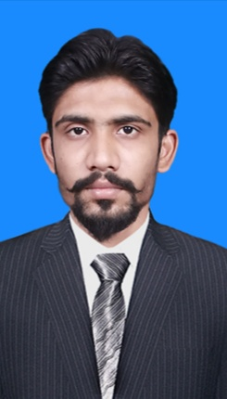
ABDUL MOHIB SHAIKH

Personal Information
•  •  •  •  •  •  • | Father’s Name  Surname  CNIC #  Date of Birth  Domicile  Marital status  Religion | Hashim Ali  Shaikh  44103-2359382-9  25-02-1996  Mirpurkhas Sindh  Married  Islam

Experiences

2026
Lecturer: Currently Teaching in University of Mirpurkhas as Visiting Faculty of Islamiyat
2015-2018
Science Teacher: Class 6th to 8th Eastern Public School Mirpurkhas
^{Hameed Pura Colony} Science Coordinator: Class 6th to 8th Eastern Public School Mirpurkhas

Mirpurkhas, Sindh Pakistan
Biology Teacher: Class 9th Eastern Public School Mirpurkhas

0312-3743801
Islamiyat Teacher: Class 6th to 10th Eastern Public School Mirpurkhas
Mohibshaikh30398@gmail.com 2019 August to January

History Teacher: Class 6th to 8th Vision School Mirpurkhas
Pakistan studies Teacher: Class 6th to 8th Vision School Mirpurkhas
- January to 2020
Campus Head: Class 6th to 10th Eastern Public School Mirpurkhas
- September (continue)
Project Manager: Forging The Future School Mirpurkhas

Professional Engagement
- Science Syllabus: Work in Research and Development Centre (R&D) compile Islamiyat Syllabus
- Worksheets: Review worksheets of Science, Islamiyat, and Social Studies (R&D)
- Trainer: Give trainings on following topics in different Schools
1. Classroom Reading
2. Copy checking
3. Bloom’s Taxonomy
4. What is the Syllabus and Scheme of studies?

5. Classroom management
• Arts Foundation (NGO): Part of Social Action Project (SAP) in different villages of interior Sindh

EDUCATION
Masters in Islamiyat: 2nd Division
DAE (electrical engineering): 3rd Division
Molvi Alim Fazil: 2nd Division

Professional Development Courses
- Arabic Course: 3 months from Taeseer ul Quran by Molana Ateeq ur Rehman
- DNA of Knowledge: Three days’ workshop by DR Abdul Wahab Suri Karachi university
- DNA of Motivational Speaker: Three days’ workshop by DR Abdul Wahab Suri Karachi university
- Seerat e Rasool SAW: 6 month workshop by DR Ahmed Imtenan Kashif

- Teaching Methodology: Three days’ workshop by Professor Abbas Hussain (TDC)
- How to make Activities: Three days’ workshop by Professor Ali Akbar (Author of Karwan Urdu)
- Clubs Instead of Classroom: Two days’ workshop by Salman Asif Siddique ERDC

