Dr. Izaz Ullah Khan
High School Koroona, Malik Abad, Post Office
Nisatta (24450), Tehsil & District Charsadda,
Khyber Pakhtunkhwa, Pakistan.
Email: izaz1982@yahoo.co.uk, Skype ID drizazukhan
Passport: ZQ4100624, Date Issue, 3 Jan 2025, Date Expire, 2 Jan 2030. https://orcid.org/0000-0002-3826-8657 Phone # 0092-0332-1511950, 0092-0300-5849721
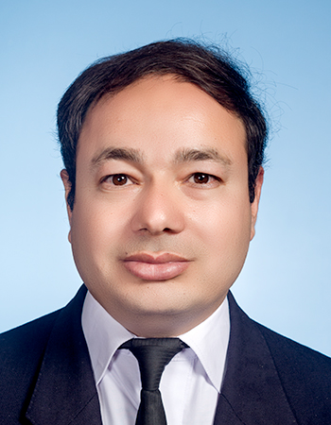
RESEARCH INTEREST
Mathematics, Data Science, Artificial Intelligence, Machine Learning, Quantum Machine Learning, Deep Learning, Neural Networks, Mathematics of Artificial Intelligence, Generative AI, Vertex AI Studio, Azure Machine Learning Studio, Tensor Flow, Google COLAB, Kaggle, Advanced Python, Python Web Scraping, Beautiful Soup, APIs, Python for Finance, Industrial Engineering, Operations Research, Fuzzy Mathematical Modeling, Game Theory, Quantitative Techniques, Mathematical Economics, Data Envelopment Analysis, Agentic AI, CrewAI. N8N Automation.
Diploma
Digital Marketing Agency
Word Press and E commerce
Stridesol automation software
Top Scientist in the World 2025 and 2024 Ranking
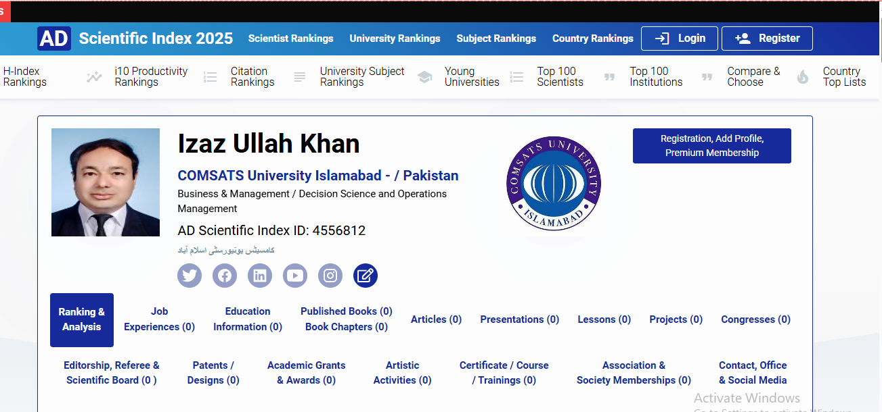
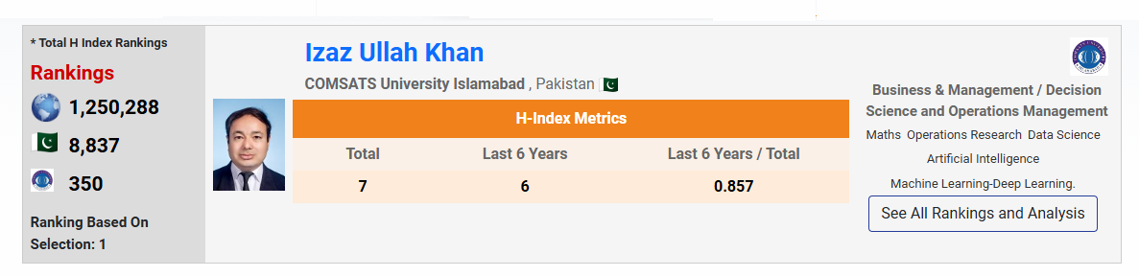
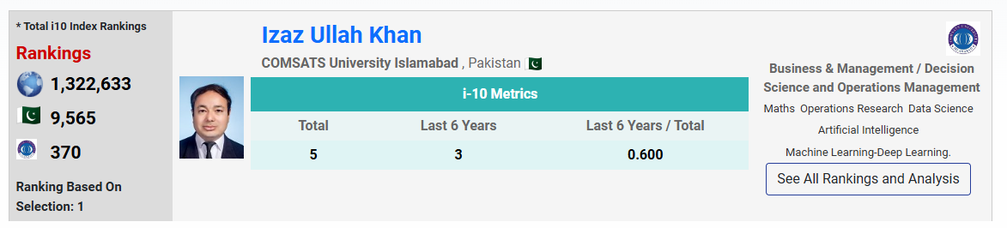
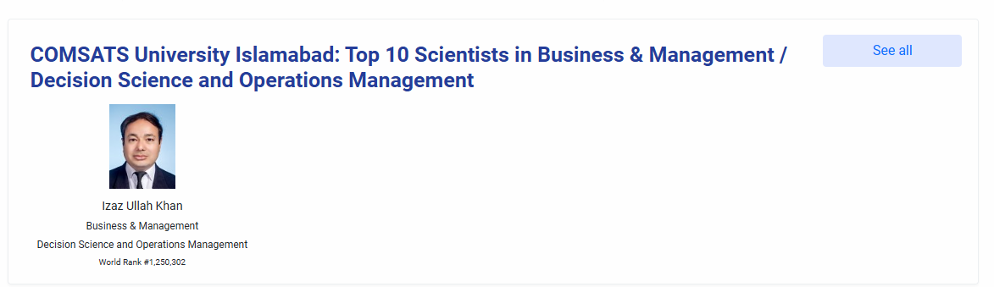
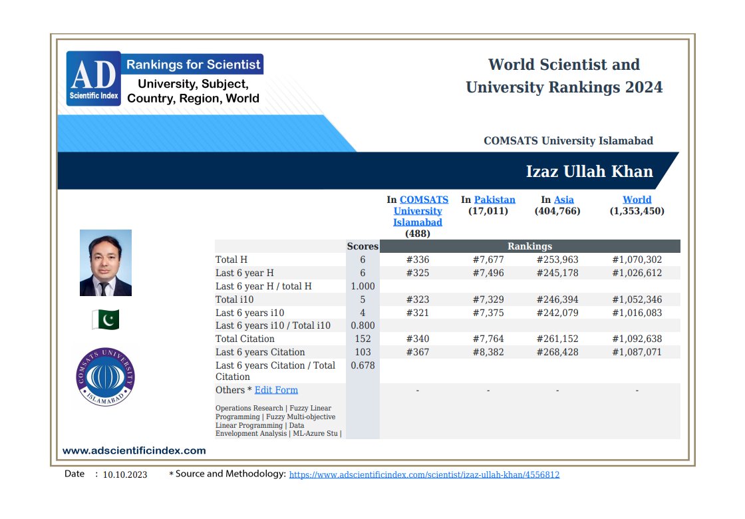
OBECTIVES
+ To introduce and propose new degree programs in the area of Operations Research, Fuzzy
Mathematical Modeling, Operations Management, Logistics & Supply Chain, Management
Sciences, Data Envelopment Analysis.
+ Proposals for new programs at BS, Masters and PhD level.
+ Establish new links with the world especially Malaysia, Iran and Turkey for collaboration and
degree requirements.
+ Proposal to establish Business Analytics Lab, Center of Excellence in Operations Research,
Business Intelligence Software Lab.
+ One MS student completed thesis on “Fuzzy linear programming formulation for minimum cost
capacitated fuzzy network and its implementation to minimize the operations cost of an airline,
Case of American Airline”.
+ One MS student completed thesis on “A novel dynamic fuzzy linear programming formulation
and its implementation for optimal resource planning of the education system in Pakistan”.
+ Intelligent Business Analytics using Data Envelopment Analysis for US Airlines.
+ Three students worked on Fuzzy Neural Networks, quadratic programming, and portfolio
Optimization in capital market structure.
+ Azure Machine Learning Studio, Tensor Flow.
+ One of my brilliant student “Muhammad Shahbaz Shah” got fully funded scholarship from University of Tennessee, Knoxville, USA in the field of Industrial Engineering. Shah Masters research was related to “Fuzzy Neural Networks for Fuzzy Quadratic Programming and Portfolio Optimization in Capital Market: Case of Pakistan Stock Exchange”.

EXPERIENCE (Total Teaching & Research Experience: 19 Years)
- Assistant Professor in Mathematics & Operations Research (OG-111), COMSATS University Islamabad, Abbottabad Campus, Pakistan.
July 2013 To Date. (13 Years)
- Research Assistant, Universiti Teknologi Malaysia.
June 2010 To July 22nd 2013. (3 Years)
- Lecturer in Mathematics, (Teaching MBA) COMSATS University Islamabad, Abbottabad Campus, Pakistan.
August 2006 To June 2010. (4 Years)
ADMINSTRATIVE EXPERIENCE
- Sep. 2008 to Sep 2009: Warden Hostel 3,COMSATS Institute of Information Technology, Abbottabad, Pakistan
- Sep. 2008 to June 2010: Member Hostel Discipline Committee, COMSATS Institute of Information Technology, Abbottabad, Pakistan
- Sep. 2009 to June 2010: Warden Hostel 1,COMSATS Institute of Information Technology, Abbottabad, Pakistan
- Mar. 2009 to June 2010: Senior Faculty Proctor, COMSATS Institute of Information Technology, Abbottabad, Pakistan.
- Research Head Analysis Group, Mathematics, COMSATS Institute of Information Technology, Abbottabad, Pakistan.
- Course Head of Operations Research, COMSATS Institute of Information Technology, Abbottabad, Pakistan.
- MS Mathematics, Admission Campaign Committee, COMSATS Institute of Information Technology, Abbottabad, Pakistan.
- Member Organizing Committee Symposium CCISE 2006, 2007, 2008, 2009,2010, 2014, 2015, 2016. COMSATS Institute of Information Technology, Abbottabad, Pakistan.
- Member Facilitation Committee Symposium CCISE 2006, 2007, 2008, 2009,2010, 2014, 2015, 2016. COMSATS Institute of Information Technology, Abbottabad, Pakistan.
- Paper Quality Checking Committee, Mathematics, COMSATS Institute of Information Technology, Abbottabad, Pakistan.
- Member Campus Academic Review Committee CARC. COMSATS Institute of Information Technology, Abbottabad, Pakistan
- Head of the SOS of BS Mathematics program. COMSATS University Islamabad, Abbottabad Campus, Pakistan, 2020.
- Course Contents Reviewer of Operations Research, SOS of BS Mathematics program. COMSATS University Islamabad, Abbottabad Campus, Pakistan, 2020.
- Course Contents Reviewer of Optimization, SOS of BS Mathematics program. COMSATS University Islamabad, Abbottabad Campus, Pakistan, 2020.
- Course Contents Reviewer of Nonlinear Optimization, SOS of BS Mathematics program. COMSATS University Islamabad, Abbottabad Campus, Pakistan, 2020.
- Course Contents Reviewer of Numerical Optimization, SOS of BS Mathematics program. COMSATS University Islamabad, Abbottabad Campus, Pakistan, 2020.
- Research Head Analysis Group, Mathematics, COMSATS Institute of Information Technology, Abbottabad, Pakistan, 2022-2023.
- Group Leader Pre-Calculus 1 and Pre-Calculus 2, 2023.
- BS Admission Committee, 2022-2023.
- MS Admission Committee, 2021, 2022, 2023.
- Member Quality Enhancement Cell QEC Mathematics Department, 2024-2025.
- Member BS Admission Committee, Mathematics, 2024-2025.
- Member Department Academic Review Committee DARC, 2024-2025
- Head of Analysis Research Group, 2026
- Member of the QEC Committee, 2025-2026
EDUCATION
• M.sc (Mathematics) University of Peshawar 2005
- M.sc(Economics) University of Peshawar 2009
- PhD (Mathematics, Specialization in Operations Research)
University Technology Malaysia 2013
Ph. D Title:
Feed Back Fuzzy State Space Modeling for Solving Inverse Problems in a Multivariable Dynamical System

Fellowship
Government Analytics Fellowship-2025, by World Bank Institute of Economic Development.

Education Qualification in Tabular Form.
Certificate/  Degree | Duration  of studies | School/Board/University | Total  Marks | Obtained Marks | % | Division
Matriculation  Science | 1996-1998 | BISE Peshawar Pakistan. | 850 | 683 | 81 | First /  A-1
FSc  Pre Engineering | 1998-2000 | BISE Peshawar  Pakistan. | 1100 | 773 | 70 | First / A
BSc  Computer Science+Mathematics | 2000-2002 | University of Peshawar Pakistan. | 550 | 361 | 65 | First
MSc  Mathematics | 2002-2005 | University of Peshawar  Pakistan. | 733 | 1100 | 66.6 | First
MSc  Economics | 2007-2009 | University of Peshawar  Pakistan. | 743 | 1200 | 61.9 | First
PhD  Mathematics Specialization in Operations Research | 2010-2013 | Universiti Teknologi Malaysia | A | A |  | First / CGPA A

M PHIL STUDENT SUPERVISED
1 Muhammad Aftab, FA14-R03-001, Dynamic Programming Approach for Solving Fuzzy Linear Programming Problems.
2 Faisal Khan, Minimum Cost Capacitated Fuzzy Network and its Application to reduce the Flight Delay Cost of an Airline. COMSATS University Islamabad, Abbottabad Campus, Pakistan.
3. Zahoor Ahmad, Multiobjective Convex Separable Programming and its Application for Portfolio Optimization Problems in Capital Market Investment
4. Muhammad Shahbaz Shah, Fuzzy Artificial Neural Networks for Solving Fuzzy Quadratic Programming Problems and its Application to Portfolio Optimization Problems in Capital Market.
5. Muhammad Amir, Penalty Method for Fuzzy Quadratic Programming Problems with Fuzzy Neural Networks and its Application to Portfolio Optimization Problems.
6. Raja Osama, Fuzzy Quadratic Programming Problem with Back propagation Fuzzy Neural Network and its Application to Portfolio Optimization Problems.
Paper Reviewed by Prof Emeritus Lotfi Aliaskar Zadeh (L) Founder of Fuzzy Logic and Fuzzy Theory
Izaz, U. K., Ahamd, T. and Normah, M. (2013). A Simplified Novel Technique for Solving Fully Fuzzy Linear Programming Problems. Journal of Optimization Theory and Applications. DOI 10.1007/s10957-012-0215-2. ISI IF: 1.42. http://link.springer.com/article/10.1007%2Fs10957-012-0215-2
HOUNOURS AND AWARDS
- Awarded MERIT SCHOLARSHIP by the Provincial Govt of N.W.F.P in 1998, for outstanding position in Secondary School Certificate (SSC) Examination.
Paper Reviewed and accepted by Professor Emeritus Lotfi Ali Askar Zadeh “Founder of the Fuzzy Set Theory” A Simplified Novel Technique for Solving Fully Fuzzy Linear Programming Problems. Journal of Optimization Theory and Applications. DOI 10.1007/s10957-012-0215-2. ISI IF: 1.6.
SPECILIZATION
Machine Learning, Data Science, Artificial Intelligence, Operations Research, Optimization, Data Envelopment Analysis, Linear Programming, Fuzzy State Space Modeling, Neural Networks and its Application in Business, Economics and Education.
RESEARCH INTEREST
- Artificial Intelligence, Data Science, Machine Learning, Deep Learning, Neural Networks, Google COLAB, Kaggle, Python, Feedback Fuzzy State Space Modeling.
- Linear Programming, Fuzzy Linear Programming, Simplex-Fuzzy Simplex Algorithm and its Applications in Business, Economics and Education.
- Google Colabortory, Azure Machine Learning Studio, Tensor Flow.
- Multi criteria Decision Making, Data Envelopment Analysis (DEA) and its Applications in Business, Economics and Education.
- Python Web Scraping, Beautiful Soup, APIs, Python for Finance.
PROJECTS
- FFSSM, DYNAMIC PROGRAMMING, PARAMETRIC PROGRAMMING
- DATA ENVELOPMENT ANALAYSIS AND PRODUCTIVITY ANALAYSIS
- Google Colabortory, Azure Machine Learning Studio, Tensor Flow
COURSES TAUGHT
- Operations Research, Linear Programming | - Business Mathematics I & II
- Optimization i | - Business Statistics
- Optimization ii | - ODE
- Convex Optimization | - Multivariable Calculus
- Dynamic Programming | - Calculus and Analytical Geometry
- Linear Algerba | - Biostatistics
- Numerical Optimization | - Numerical Linear Algebra
- Fuzzy Logic and its Applications | - Numerical Computation

Techniques, Methods and Expertise
Linear Programming, Parametric Programming | Multi objective linear programming
Quadratic Prorgamming | Data Envelopment Analysis
Karush Kuhn Tucker Conditions | Sequential Unconstrained Max/Min Techniques
Lagranges Method and Jacobian Method | Geometric Programming
Stochastic Programming, Multiobjective goal programming | Separable Programming
Integer and Mixed Integer Programming | Gradient Decent / Ascent Method
Azure Machine Learning Studio, Tensor Flow | Convex Programming
SKILLS AND SOFTWARES

Python, Python Machine Learning, Python Web Scraping, Beautiful Soup, APIs, Python for Finance, MINITAB, MATLAB, KONSI DEA SOFTWARE, LINDO AND LINGO SOFTWARE, Google COLAB, Kaggle, Python, Data Science.
Courses from Data Science 365
- Python for Finance
- Deep Learning with Tensor Flow
- Introduction to Tableau
- Power BI
- Customer Analytics with Python
- Convolution Neural Network with Tensor Flow in Python
- Deep learning with Tensor Flow
- Web Scraping and API Fundamentals in Python
Course
Forward Program of McKensy and Company

REVIEWER
IEEE Transactions on Cybernetics
Intelligent Automation & Soft Computing
Journal of Optimization Theory and Applications.
International Journal of Uncertainty, Fuzziness and Knowledge-Based Systems
Journal of Intelligent and Fuzzy Systems
International Journal of Fuzzy Systems
Fuzzy Systems and Data Mining FSDM 2017, 2018.
Technical Program Committee of Fuzzy Systems and Data Mining FSDM 2018, Thailand.
Journal of Intelligent and Fuzzy Systems
Member Institute of Operation Research and the Management Sciences INFORMS
American Association of International Researchers.
American Research Institute for Policy Development ARIPD.
ARO Journal
RESEARCH AND PUBLICATIONS (ISI, ESCI, SCI)

 | Title of Publication | Publisher | Year | Volume | Page # | Impact Factor
14 | Operational Task Scheduling of the Kernel Based on Intuition and linear Optimization | Open Engineering | 2026 | Accept |  | 1.5
13 | Machine Learning for Multi Objective Convex Separable Programming (MOCSP) with Aggregation of Linear Approximations and Portfolio Optimization | Foundations of Computing and Decision Sciences (FCDS) | 2026 | Published |  | 1.3
12 | Fuzzy neural network with back propagation for fuzzy quadratic programming problems and portfolio optimization problems | Nonlinear Engineering. Modeling and Application | 2024 | Published |  | 2.3
11 | Fuzzy Neural Network for Fuzzy Quadratic Programming with Penalty Function and Mean Variance Markowitz Portfolio Model | Applied Computational Intelligence and Soft Computing | 2024 | Published |  | 2
10 | Machine Learning for Markov Modeling of COVID-19 Dynamics Concerning Air Quality Index, PM_{-2.5}, NO₂, PM₋₁₀, and O₃ | Int j. Computational methods and experimental measurements | 2024 |  |  | 0.46
9 | Adaptive Fuzzy Dynamic Programming (AFDP) Technique for Linear Programming Problems LPs with Fuzzy Constraints | Soft Computing | 2023 | 19(27) | 13931–13949 | 4.2
8 | An inappropriate rise in NO2 during the pandemic of COVID-19 in the urban area of Chhattisgarh, India | Nature Environment and Pollution Technology | 2023 | 22(2) | 671-680 | 0.74
7 | Dynamic Programming Approach for Solving Fuzzy Linear Programming Problems FLPs and its Application to Optimal Resource Allocation Problems. | Journal of Intelligent and Fuzzy Systems | 2022 | 42(4) | 3517-3535 | 1.7
6 | Minimum cost capacitated fuzzy networks, its linear programming formulation and perspective data analytics to minimize the operations cost of America Airlines. | Soft Computing | 2021 | 25 | 1411–1429 | 3.73
5 | The Effects of Weather on the Dynamics of COVID-19 Using Eigen Space Decomposition. | Computers, Materials and Continua. | 2021 | 69(3) | 3047-3063 | 4.89
4 | Revised convexity normality and stability properties for the feedback fuzzy states space model dynamical system of the insulin glucose regulatory system in humans. | Soft computing | 2019 | 23 | 11247–11262 | 3.73
3 | Intelligent business analytics using proposed input / output oriented data envelopment analysis DEA and slack based DEA models for US-Airlines | Journal of Intelligent and Fuzzy Systems, | 2019 | 37, no. 6 | 8207-8217 | 1.7
2 | A Reply to a Note on the Paper “A Simplified Novel Technique for Solving Fully Fuzzy Linear Programming Problems | Journal of Optimization Theory and Applications. | 2017 | 173 | 353–356 | 2.18
1 | A Simplified Novel Technique for Solving Fully Fuzzy Linear Programming Problems. | Journal of Optimization Theory and Applications. | 2013 | 159 | 536–546 | 2.18

RESEARCH AND PUBLICATIONS (Others)

 | Title of Publication | Publisher | Year | Volume | Page # | Impact Factor
8 | The Notion of Stability of a Differential Equation and Delay Differential Equation Model of HIV Infection of CD4+ T-Cells | International Journal of Mathematics and Computers in Simulation | 2021 | 15 | 20-23
7 | The Notion of Duality in Fully Intuitionistic Fuzzy Linear Programming (FIFLP) Problems | International Journal of Fuzzy Systems and Advanced Applications | 2016 | 3 | 20-26
6 | AN INVERSE FEEDBACK FUZZY STATE SPACE MODELING OF INSULIN-GLUCOSE REGULATORY SYSTEM IN HUMANS. | Scientific Research and Essays | 2013 | 8(32) | 1570-1583
5 | On the Structural, Number Theoretic and Fuzzy Relational Properties of Large Muli-Connected Systems of Feedback Fuzzy State Space Models (FFSSM’s). | Journal of Applied Sciences Research. | 2012 | 8(2) | 1103-1113. | Scopus IF: 0.308.
4 | Feedback Fuzzy State Space Modeling and Optimal Production Planning for Steam Turbine of a Combined Cycle Power Generation Plant. | Research Journal of Applied Sciences. Scopus IF: 0.493. | 2012 | 7(2) | 100-107.
3 | OPTIMAL PRODUCTION PLANNING FOR ICI PAKISTAN USING LINEAR PROGRAMMING AND SENSITIVITY ANALYSIS. | International Journal of Business and Social Sciences | 2011 | 2(23) | 206-212
2 | Fully Fuzzy Linear Programming (FFLP) with a Special Ranking Function for Selection of Substitute Activities in Project Management. | International Journal of Applied Science and Technology. 1(6): 234-246. | 2011 | 1(6) | 234-246.
1 | A Two Phase Approach for Solving Fuzzy Linear Programming Problems with Trapezoidal Membership Functions. | International Journal of Basic and Applied Sciences. 10(6): 86-95. | 2010 | 10 | 86-95.

RESEARCH STATEMENT
My research philosophy is to spread the true knowledge of my research field in the world. To save my area of research from being obsolete in the rapidly changing high technological world, and elaborate the real world application scenarios of my research field. To draw conclusions and insight from my experiments and field of research applicable to the real world problems. Furthermore, to learn, to teach, then to act upon it and implement it, then to do research, and finally to leadership and plan are my main teaching and research objectives. My PhD from Univerisiti Teknologi Malaysia (UTM) in 2013 is in the field of Mathematics with Fuzzy Modeling and Operational Research as my research interest.

My area of expertise include fuzzy / intutionisitc fuzzy linear programming, dynamic programming, geometric programming, data envelopment analysis, multi objective linear programming, productivity, efficiency, optimization and the science of better. It is a matter of great honour for me that one of my papers published in the journal of optimization theory and applications was reviewed and accepted by Professor Emeritus Lotfi Ali Askar Zadeh, the Founder of the Fuzzy Set Theory, University of California Berkeley, United States.
My areas of interest are Fuzzy linear Programming, Fuzzy Data Envelopment Analysis and Intuitionistic Fuzzy Data Envelopment Analysis, Fuzzy State Space Modeling, Neural Networks and Genetic Algorithm and its applications to Business, Economics and Education. I published papers in impact factor journal, such as journal of optimization theory and applications, journal of intelligent and fuzzy systems and soft computing. I have an aptitude for research and potentials to publish. I can carry out research in the area of performance analysis, productivity, efficiency, optimization and science of better.
My area of interest includes:
- Feedback Fuzzy State Space Modeling, Neural Networks, Genetic Algorithm, Tensor Flow.

- Linear Programming, Fuzzy Linear Programming, Simplex-Fuzzy Simplex Algorithm and its Applications in Business, Economics and Education.

- Multicriteria Decision Making, Data Envelopment Analysis (DEA) and its Applications in Business, Economics and Education.

- Planning, Optimization, Scheduling and Project Management. Azure Machine Learning Studio.

- MINITAB, MATLAB, KONSI DEA SOFTWARE, LINDO AND LINGO SOFTWARE,

- Proposal for Energy planning and Management, irrigation planning, forest area optimization problems, mining, etc, the active areas of operations research.

- Better plan the natural resources of the country, low carbon economies, industry, transportation and environmental benchmarking.
- Mathematics, Data Science, Artificial Intelligence, Machine Learning, Deep Learning, Neural Networks, Mathematics of Artificial Intelligence, Generative AI, Vertex AI Studio, Azure Machine Learning Studio, Tensor Flow, Google COLAB, Kaggle, Python, Python Web Scraping, Beautiful Soup, APIs, Python for Finance, Industrial Engineering, Operations Research, Fuzzy Mathematical Modeling, Game Theory, Quantitative Techniques, Mathematical Economics, Data Envelopment Analysis, AWS cloud Computing.

- Industry and Technology driven applied research.

- Innovations and new experiments in the graduate and undergraduate teaching.
Teaching Statement
My teaching philosophy is to help make humanity stronger by the power of knowledge. To spread the true knowledge all around the world without any discrimination of caste, creed, color, regional, socio-economic and socio-political bounds. To remove the darkness of ignorance by the light of truth, knowledge and reality. To spread the slogan of peace, prosperity, serenity, happiness, beauty of existence by the power of knowledge, teaching, and educating the others. Furthermore, to learn, to teach, then to act upon it and implement it, then to do research, and finally to leadership and plan are my main teaching and research objectives.
Every real world system can be more accurately modeled in the language of mathematics called mathematical modeling. The fact that mathematics can address the real world is accepted upon.
I have fourteen years teaching / research experience at university level in “COMSATS Institute of Information Technology, Abbottabad, Pakistan”. I have taught courses to Master of Business Administration MBA, Bachelor of Business Administration BBA, Bachelor of Electrical Engineering BEE etc. The courses I taught include Numerical Computation, Business Mathematics and Statistics to MBA, Business Mathematics I, Business Mathematics II, Introduction to Statistics, Biostatistics, Linear Algebra, Calculus 1, II, III, Calculus and Analytic Geometry, Optimization I, Optimization II, Operations Research. Optimization Theory to MS Mathematics students. My Ideals as a good teacher:
- The process of teaching and learning occurs in a very peculiar environment. This environment should be equipped with a potential resource person, eligible students, educational aid and technological requirements. Likewise, a research environment requires its own needs and necessities, like internet facility, access to international databases, exposure and expertise. I can adapt to both situations in most benefiting manner.
- Before starting the teaching learning I make sure to be fully confident of myself, resourceful and know all about what I am going to deliver in the class.
- At the beginning of every lecture repeat the previous knowledge of the students.
- I always go down to the students understanding of the subject. Repeat previous knowledge, and then go for further learning.
- Teaching should be at the level of the receiver, that is, the student. At the end of the teaching / learning process the required objectives should be achieved.
- A good resource person always has its own teaching methodology, which make a difference from the others.
- At the end of the class I make sure the drafted goals have been achieved.
- Feedback the students about the knowledge gained. Its application in the real world problem solving.
My experience as a teacher has benefited me to:
- Develop lesson plans on a wide range of topics and varying levels of academic ability.
- Develop a high level Curriculum and course contents of Mathematics for a high prestige IT University.
- Work with emotionally and physically challenged students in a total inclusion program.
- Observe and participate in effective classroom management approaches.
- Assist with parent-teacher associations.
- Debates and sessions on diversity, math and reading skills, and community relations.
- Enthusiastically participated in Organizing National and International level Conferences, Convocations and Symposia, a few naming TECHNOMOOT 2007-2008, 2009, 2010, 2013, 2014, 2015, 2016, EMCOT07-08, CSE07-08, CCISE07-08.
- Participated in Human Resource development Workshops at Abbottabad, Lahore, Pakistan.
- Develop a strong aptitude for research.

