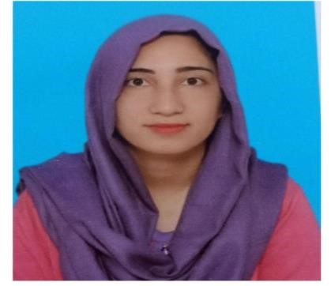
Falak Naz
Cell: +923115299088
Address: Lane#7 house near Ayub Masjid, Sadiq town Dhama mour, Adyala Road, RWP.
DOB: 28-09-1999

Email: nazzfalakunain786@gmail.com

CAREER OBJECTIVES
- Seeking a position where my qualification and work experience can add value to the operations of the organization.
- To obtain the position of Student Services and Registration Officer, where I can utilize my organizational skills, attention to detail, and strong communication abilities. I aim to contribute to the smooth registration process, maintain accurate student records, and provide excellent support to students. My goal is to enhance the overall student experience and support the university's operations efficiently.
- I'm looking for a job in an educational organization where I can put my skills to good use, whether it's in administration, communication, or helping solve problems. I want to contribute to the smooth running of the organization, support students, and be part of creating a positive learning environment. I'm excited to grow and learn while helping the organization reach its goals.

QUALIFICATION

M. Sc. (Hons) Horticulture (almost complete with 3.57CGPA waiting for an official notification). PMAS Arid Agriculture University Rawalpindi, Pakistan.

B.Sc. (Hons) Agriculture-Horticulture (2018-2022) PMAS Arid Agriculture University Rawalpindi, Pakistan. (CGPA 3.49/4).
- Internship: Worked in Ztbl.Farms Margalla Town Islamabad on kitchen gardening and maintenance of nursery.
- HSSC: Intermediate in Pre-medical from AQ Khan College Harley Street. Secured 685/ 1100
- SSC: Matriculation in Science from Public School 208- Humayun Road Campus Rawalpindi. Secured 751/1050
WORK EXPERIENCE
- Presently working as, a Learning facilitator at Senpi.
- Worked as an English Teacher in Roots Garden School Adyala Road Campus (Duration:4 months).
- Worked as an internee in IIUI School Campus Ali Town (Duration:2 months).
- Worked as an online and home tutor from past 2019-2025.

SKILLS
- Able to maintain and update student records and databases accurately.
- Familiar with handling student registration processes and ensuring smooth operations.
- Help with office tasks such as filing, organizing documents, and managing schedules.
- Strong ability to respond to student queries and explain processes clearly.
- Efficient in Microsoft Office Packages.

