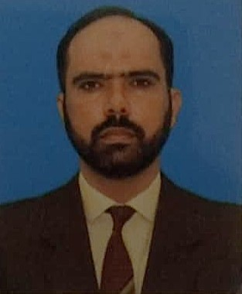
NAVEED AKBAR

Administrator / Store In charge / Physical Fitness Trainer

CONTACT INFORMATION

- 03334127454 /mehareman900@gmail.com /  Punjab, Pakistan

EDUCATION

2011 – 2013 : M Sc (Health and Physical Education)
Sarhad University of Science and I.T Peshawar, Pakistan

EXPERIENCE

2003 – 2025 : SNCO
Pakistan Air Force
22 Years of Administration, Store In charges and imparting Physical Education and training.

COURSES

SNCOs Disciplinary Course Military Leadership and Command Course

SEP Supervisory & Management Course Crash Course (Fitness Course)

Special Fitness and Grooming Course Basic Computer Course

SKILLS

Administration and supervisory Experiences Inventory and Funds Management

Sports And Physical Training Experience Office Management

Exceptional Computer Approach Efficiently handling of all types of tasks assigned

KEY ACHIEVEMENTS

Distinguished Service Record of 22 years

Recognition certificates of different types of tasks performed during entire career

