
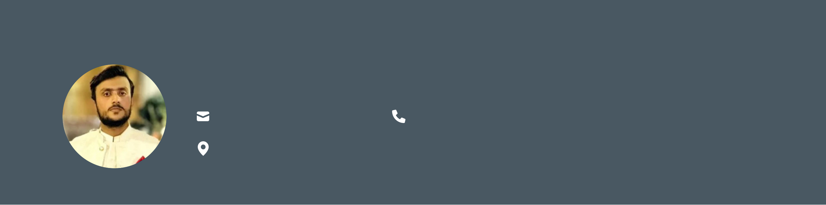
Rao M Tanzeel Raza Computer Scientist

Raotanzeem@gmail.com

0307-2993420 / 0335-5085947

Rawalpindi/Islamabad, Pakistan
Profile
Dynamic IT student with a strong foundation in software development and design. With a background in data entry, network marketing, and a keen understanding of Microsoft Office, I am poised to excel as an Intern. Possessing adaptability, leadership, and a knack for process improvement, I bring an unwavering commitment to excellence
and the ability to thrive under pressure. My educational journey includes a diploma equivalent to F.Sc |  | , a
Bachelor of Science in Computer Science, and a solid academic background. Eager to leverage my skills and knowledge to contribute effectively to a professional setting.
Bachelor of Science in Computer Science |  | 10/2021 – 07/2025
  Education
MY University |  | Islamabad, Pakistan
Relevant Coursework: Programming Fundamentals (PF), Mobile Application Development (MAD), Principles of Artificial Intelligence (PAI), Natural Language Processing (NLP), Computer Vision (CV), Computer and Network Security (CNS)
Years Diploma Equal to F.Sc  CTTI College  Matriculation  Army Public School FWO | 2018 – 2021  Islamabad,Pakistan  2017 – 2018  Rawalpindi, Pakistan

Professional Experience
IT Executive  Software Medicare Technology Software |  | 2023 – Present Rawalpindi, PK
 | •Managed day-to-day IT operations, ensuring smooth functioning of software systems, | 2023 – Present Rawalpindi, PK
hardware infrastructure, and networks.
•Provided technical support and troubleshooting for software applications, system errors, and network connectivity issues.
•Assisted in software deployment, updates, and configuration to meet organizational requirements.
•Collaborated with development and operations teams to ensure seamless integration of software solutions.
•Maintained data security protocols and performed regular system backups to safeguard business-critical information.
•Monitored system performance and recommended upgrades to improve efficiency and reliability.
•Documented IT processes and trained staff on effective use of company software and technology tools.
Key Achievements:
•Streamlined IT support processes, reducing downtime and improving response time.
•Contributed to successful rollout of new software tools within the organization.

•Strengthened cybersecurity measures, minimizing risks of unauthorized access and data loss.
IT Support Specialist 02/2023 – 10/2023 PC Store Islamabad, PK
•Provided technical support to end-users for hardware, software, and network issues, ensuring minimal downtime.
•Installed, configured, and maintained desktops, laptops, printers, and peripheral devices.
•Assisted customers in troubleshooting operating systems, applications, and antivirus solutions.
•Performed routine system maintenance, updates, and backups to improve device performance.
•Guided clients in selecting appropriate hardware/software solutions based on their requirements.
•Documented common technical issues and solutions to streamline future troubleshooting.
Key Contributions:
•Improved customer satisfaction by resolving technical queries efficiently.
•Reduced average issue resolution time through effective problem analysis and solution delivery.
•Supported sales team by providing technical insights into product specifications and compatibility.
IT Product Specialist 2021 – 2022 Various Organizations ISB/RWP, PK Provided hardware and software support, assisted with PC setup and troubleshooting,
and advised on IT products.
Technical Skills  •Programming (C++, Java, Python)  •AI: NLP, Computer Vision, PAI  •Networking & Security  •Microsoft Excel  •Microsoft PowerPoint  Professional Skills  •Adaptability  •Ability to Work Under Pressure  •Leadership  •Communication & Teamwork  •Problem-Solving & Analytical Thinking
  Skills

Natural Language Processing (NLP) Projects |  | 2025 – 2025
  Projects
Built applications leveraging NLP techniques for text classification, sentiment analysis, and language processing. Applied Python libraries (NLTK, spaCy, etc.) for text
preprocessing and model training
Final Year Project: Automated Vehicle Identification using QR Code Camera Scanner 2024 – 2025 Developed a system to automatically identify vehicles using QR codes and camera-based
scanning. Implemented in Java with integration of image processing techniques.
Improved vehicle entry/exit efficiency and enhanced security validation.

Android Virtual App 2023 – 2023 Designed and deployed an Android-based virtual application on a laptop using Java.
Implemented core features such as UI design, data handling, and interactive user functions.
Computer Vision (CV) Projects 2025 – 2025 Developed image recognition and object detection models using OpenCV and machine
learning approaches. Worked on feature extraction, classification, and camera-based
real-time analysis.

