Curriculum Vitae
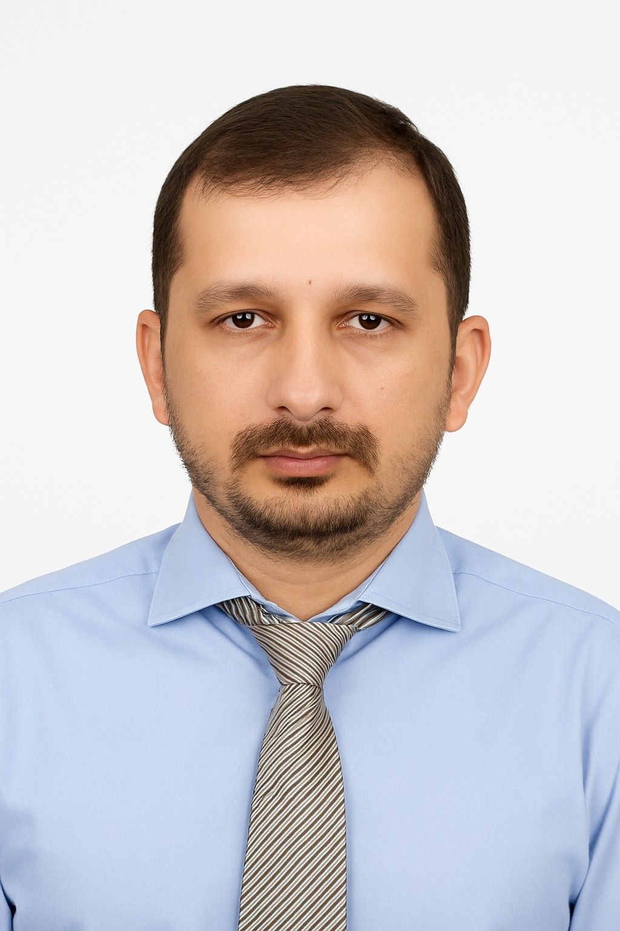

Name: Wasif Mir
Address: House 10, St 3,lawyers Town Chaklala
Phone: +92 333 5526308
Email: wmir278@gmail.com
Linked In: https://www.linkedin.com/in/wasif-mir-80675660/

Professional Profile
Dedicated finance professional with over 10 years of experience in accounting, financial management, and reporting across the real estate and education sectors. Currently serving as Assistant Manager Finance in Dr. A.Q. Khan College of Science & Technology with responsibility for managing budgeting, audits, reporting, and fee collection for 4,250 students. Proven track record in preparing financial statements, implementing internal controls, managing accounts payable/receivable, and ensuring compliance with taxation and regulatory requirements. Holds B.Com, MBA, and pursuing an MS in Accounting & Finance. Recognized for integrity, leadership, and the ability to provide financial insights that support strategic decision-making.

Career Objective
To leverage academic qualifications and professional experience in finance and accounting to contribute to organizational success, while enhancing expertise and preparing for advanced research opportunities in finance at international universities.
Work Experience

Designation | Institution | Responsibilities
Assistant Manager Finance  (1st Nov-2024 to Onwards) | DR AQ Khan College of Sciences & Technology | Developed and monitored annual budgets and forecasts, ensuring alignment with academic and operational requirements. Supervised and streamlined fee collection processes for 4,250 students, achieving 100% reconciliation and timely bank deposits.
Assistant Manager Accounts  (1st Nov-2021 to 30-Sep-2024) | Safari Villas Pvt Ltd | Contributed to diverse accounting and financial activities, encompassing accounts payable, receivable, budgeting, income statements, revenue development, and financial reporting
Assistant Accounts officer  (1st Aug-2013 to 20th Aug-2025) | Bahria Town Pvt Ltd | Assist tax filings, including Income/Sales Withholding Tax Statements. Proficient in handling diverse financial transactions (BPV's, BRV's, JV's), reconciling bank accounts, and preparing Bank Reconciliation Statements.

Education
MS in Accounting & Finance-Capital University of Sciences & Technology (C.U.S.T) (In Progress) MBA (Finance) – Mohammad Ali Jinnah University Islamabad (M.A.J.U) B.Com – Punjab University
Key Skills
- Financial Reporting (IFRS/IAS)
- Budgeting & Forecasting
- Accounts Payable/Receivable
- -Real Estate & Education Sector Finance
- MS Excel, ERP/Accounting Software
- Customized Oracle
Training
A four months training of SAF(FICO) module in which I have learned about business process in Financial Accounting, G/L,Account Receivable, Account Payable & Asset Accounting from 11th January 2016 to 28 April 2016.

References
Musawwar Ali Bangash
Manager Accounts
00923335526308
DR AQ Khan College of Sciences & Technology.
Aqkacounts.school@gmail.com
Atif Akbar
General Manager Coord & ERP
Bahria Town Pvt Ltd
00923335297217
atifrullss@gmail.com

