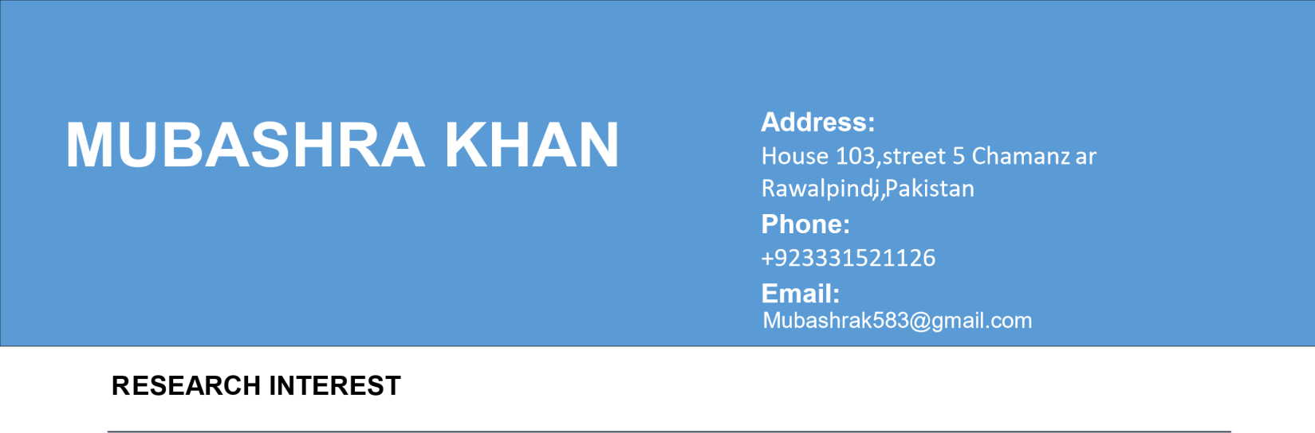
My passion lies in analyzing global issues, understanding media dynamics, and contributing to informed decision-making processes. I am particularly interested in roles that involve policy analysis, strategic communication, and research, where I can apply my skills to address complex international challenges.

EDUCATION

- BS. In Defense and Diplomatic Studies, Fatima Jinnah Women University, Rawalpindi.
- Thesis Title ; Evolving Dynamics of Jammu and Kashmir Dispute: Kashmiris Perspective “ Supervisor: Dr. Saima (Chairperson of the Department)
- MS IR (Continue)

EXPERIENCES

- Research Intern at New One
- Research Associate at Probyn security Advisors, Islamabad
- Researcher at PTV WORLD
- Content Writer at Collegium Consultancy

PUBLICATIONS

- Khan, “Socio-economic impact of Tourism on Azad Kashmir’’

CERTIFICATES AND PROJECTS

  - 1st position at an essay competition in the University which was held in solidarity to Kashmir Day focusing on developing a conflict resolution model for the Kashmir issue.
  - Model CCl Participated in Model CCI , an initiative taken by German Government in Collaboration with HEC
  - Drug Addiction Seminar, Punjab College
  - Library establishment at Orphanage
  - Certificate of Digital Journalism

