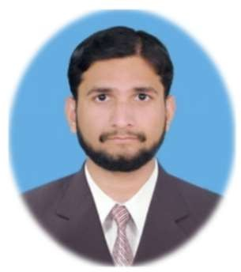
Muhammad Raza
Lecturer in Computer Science / IT

mrraza1126@gmail.com

0341-5057589
0312-7934954

House No 55/2 Street No 3 Block B,  Kehekshan Colony, Shah Poor Stop, Adyala Road, Rawalpindi, Pakistan

My objective is to join a reputed institution in order to provide innovative and quality work at a challenging position to apply and utilize my skills as a great resource for the institution and for my professional career.

EDUCATION



BS Computer Science

Preston University Kohat
Study Campus Islamabad, Pakistan 2011 – 2015

Degree Attested From
Higher Education Commission HEC
Islamabad, Pakistan

CGPA
3.9 / 4.0

WORK EXPERIENCE
Lecturer in Computer Science

IT SKILLS
- Microsoft Office
- Hardware & Software
- Web Surfing
- Digital Marketing

SOFT SKILLS
- Effective Communication
- Critical Thinking
- Problem Solving
- Leadership

CERTIFICATIONS

A+ Hardware

- Graphic Designing
- IT Problem Solver
- Social Media
- Email Handling

- Mentoring
- Teamwork
- Time Management
- Emotional Intelligence

Cadet College Sialkot
Affiliated with BISE Gujranwala 2015 – 2017
Sialkot, Sambrial, Punjab, Pakistan

Lecturer in Computer Science

Roots International College
Affiliated with FBISE Islamabad 2017 – 2018
Rawalpindi, Punjab, Pakistan

Lecturer in Computer Science

Superior Group of Colleges
Affiliated with FBISE Islamabad 2018 – 2020
Bahria Town Campus, Rawalpindi, Pakistan

Lecturer in Computer Science
Logistics Institute of Information Technology Year 2020
  - Freelancing DigiSkills Year 2021

Graphic Design
National Freelance Training Program NFTP SINA Institute of Networks & Aesthetics Year 2022

Digital Marketing
DigiSkills Year 2021

E-Commerce Training Workshop
CORVIT Networks Year 2021

ACHIEVEMENTS

Punjab Group of Colleges
Affiliated with BISE Rawalpindi Nov 2021 – Till Date
Kahuta Campus, Tehsil Kahuta, District Rawalpindi, Pakistan
- 2nd Position Summer Semester II Year 2012
- 2nd Position Fifth Semester Year 2013
- 2nd Position Fourth Semester Year 2013
- 3rd Position Sixth Semester Year 2014

LANGUAGES
– Urdu
Native

– English
Full Professional Proficiency

