EXPERIENCE
Allied School Pindigheb
CRO Customer Relationship officer and Admin
07/2025 - Present
- Developed and maintained Strong relationships With customers to ensure high levels of satisfaction and loyalty,
- Handled customer queries, complaints, and feedback through phone, email, and face-to-face interactions.
- Assisted in resolving issues promptlyto enhance the overall customer experience.
- Provided accurate information about products, services, and company policies.
Al Madina Hospital Pindigheb
Receptionist and Admin
06/2021- 02/20221 Pindigheb
- Greeted and assisted patients, Visitors, and staff With courtesy and professionalism.
- Managed front desk operations including phone handling, appointment scheduling, and patient registration.
- Maintained accurate patient records and ensured data confidentiality using Healthwire software.
- provided administrative support to doctors and nurses for smooth daily operations.
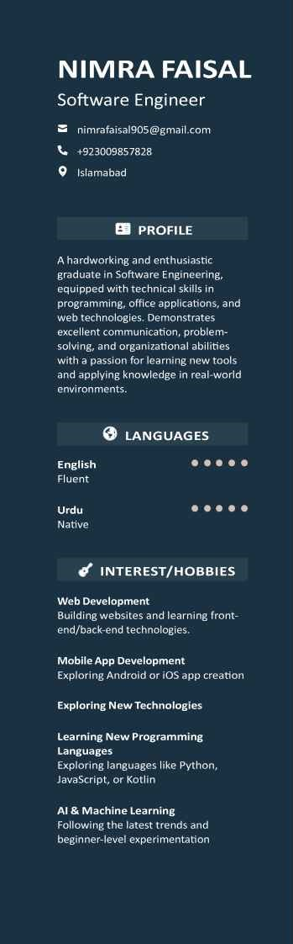
Dare Arqam school Pindigheb
Teacher
01/2021- 03/20211 Pindigheb
- Taught core subjects including Computer, Mathematics, and English to primary and middle level students.
- Prepared lesson plans, assignments, and classroom activities aligned with the school curriculum.
- Utilized multimedia tools to make learning interactive and engaging.
- Assessed student progress through quizzes, assignments. and oral presentations.
- Maintained student records, attendance sheets, and communication with parents.

EDUCATION
BSSOFTWARE ENGINEERING
Virtual university Islamabad
2025 Islamabad
Fazaia inter college MinhasKamra, Attock 20181 Attock
MATRIC(SCIENCE)
Fazaia Degree college MRF Karnra, Attock,
20161 Attock
CERTIFICATES:
- Digiskills training program
- Certificate in Freelancing
- Certificate in Graphic Design
- Diploma in Data Analytics

SKILLS
- MS Office Suite (Word, Excel, PowerPoint)
- Run software Healthwire
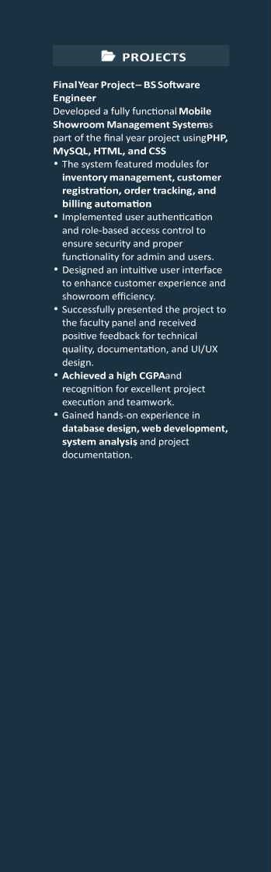
- HTML5, CSS3, Bootstrap
- JavaScript (Basic knowledge)
- Web Development (Front-end/Back-end gosics)
- Troubleshooting & Computer Maintenance
- Database Management
- Healthwire Software (Hospital management systems)
- Strong CommuniCatiOn
- Team Collaboration
. problem Solving
- Multitasking

