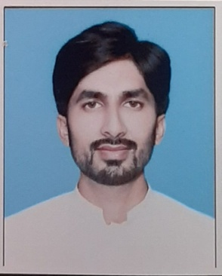 |  |  |  |  | waqas ahmad  - P.O.Box& Tehsil Paroa, DI Khan, KPK | +92-340-6055907 | w.ahmad.aslam@gmail.com  - |  Highly motivated and detail-oriented Business Administration graduate with a Bachelor of Science in Business Administration, seeking an entry-level position to leverage strong analytical, organizational, and problem-solving skills. Eager to contribute to a dynamic team and support business operations, while gaining practical experience and further developing my expertise in business management and administration.

Internship Experience
Sep 04 –  Oct 13,  2023 |  |  |  | internship, mcb islamic bank ltd.  Performed 6 weeks internship with MCB Islamic Bank Ltd. in Rawalpindi, Punjab. It was a rotational internship and helped me gain basic to mid level knowledge to branch operations, accounts opening and customer handling.

Education
Sep 2020 – July 2024 |  |  |  | bachelof science in busines adminstration  University Institute of Management Sciences, PMAS Arid Agriculture University, Rawalpindi  CGPA : 2.83
2017-2019  2015-2017 |  |  |  | Higher secondary school certificate (HSSC)  Board of Intermediate and Secondary Education, D I Khan, KPK  Subject: Pre-Engineering  Grade: A  secondary school certificate (SSC)  Board of Intermediate and Secondary Education, D I Khan, KPK  Subject: Science  Grade: A

Skills
- Microsoft Office ( MS word, Excel & Power point )
- Effective communication skills

