SHEHERYAR KHAN PhD
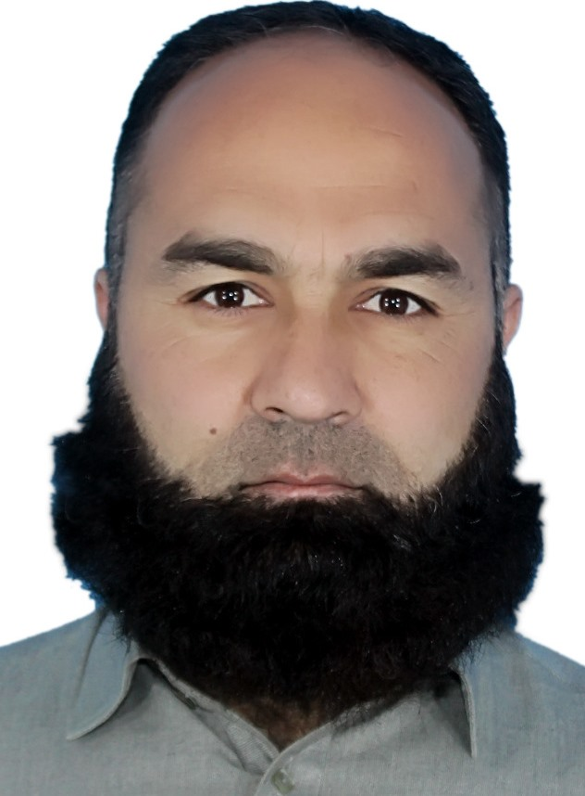
- Mobile & Whatsapp: +92-346-9442007
- Email: tsaristkhan@gmail.com
- Address: Village Kuza Bandai, Tehsil Kabal, District Swat,
Khyber Pakhtunkhwa, Pakistan

Education
- Doctor of Philosophy (PhD) 07-2024
Area Studies (China, Russia, and Central Asia) University of Peshawar
PhD Research: "Intergenerational Persistence of Child Labor Among Afghan Children: Causes and Consequences (A Case Study of Peshawar and Jalalabad)"
- Master of Philosophy (M.Phil) 12-2011
Government and Public Policy National Defence University, Islamabad
M.phil Thesis: "Post-2009 Revival of Female Primary Education in Tehsil Kabal, District Swat, Khyber Pakhtunkhwa"
Master’s Degrees
- Rural Sociology 02-2009 - Agricultural University, Peshawar
- International Relations(Private)2010 - University of Peshawar
- Education (M.Ed.)2015 - University of Malakand
M.Ed. Thesis: "Effectiveness of Pre-Service Teacher Training in Private Schools of District Swat" (2014)
Bachelor’s Degrees
- Law and Political Science (BA)2006 - University of Malakand
- Education (B.Ed. 2009) - University of Peshawar
- Pre-Master’s2010-11 Program Kaplan International College, United Kingdom
Certificates
- E-learning Protecting Sports Together 2024 (online)
Sport Integrity Australia
- Chinese Language 2020 (Online)
Axinstitute for Chinese Language, Karachi
Research and Publications
Research Interests: Child protection, education, and geopolitical dynamics of China, Russia, Central Asia, and Afghanistan
Publications
- Khan, S., & Ibrar, M. (2023). Causes and Consequences of Child Labor on Children’s Health: A Case Study of Afghan Refugee Child Laborers in Peshawar. Journal of Social Sciences Review, 3(2), 435–445. DOI: 10.54183/jssr.v3i2.131
- Khan, S. (2024). Socioeconomic Factors Influencing Child Labor and Educational Opportunities in Afghan Refugee Communities in Peshawar and Jalalabad. International Journal of Human Sciences.
- Shah, B., Khan, S., & Shah, R. (2025, 01 22). ASIA’S QUEST FOR STABILITY: REGIONALISM AS A GEOPOLITICAL STRATEGY. Sociology & Cultural Research Review, 04(03), 866-874.

Professional Experience
- The Town Public School and College Kanju Swat
(April 10, 2012- March 31, 2013)

- Swat Public School and College (SPS) Rahimabad, Swat
(August 14, 2013- September 28, 2015)
(1st August, 2016- 31 October, 2018)

Lecturer: Pakistan Studies
Workshops and Webinars
- World Day for the Prevention of Child Abuse (2024)
International Society for the Prevention of Child Abuse & Neglect (ISPCAN)
- Collaborative Response Frameworks for Child Sexual Abuse (2024)
International Society for the Prevention of Child Abuse & Neglect (ISPCAN)
- Design of Scientific Research Processes (2024)
University of Peshawar
- Recognizing and Reporting Child Abuse (August 2025)
Center for Child Protection a Children Advocacy Center Texas USA
Languages
- English (Fluent)
- Urdu (Fluent; National Language)
- Pashto (Mother Tongue)
- Russian, and Chinese Beginner Level
Key Skills
- Teaching
- Pakistan Studies
- Sociology
- Area Studies
- Research and Academic Writing

