Curriculum Vitae for the Post of English Lecturer
Name: Irfan Afzal 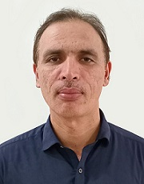
Contact no: 03336417122
Email ID: irfanafzal.j@gmail.com
Address: House no.581, street No.25, G-16/4, Islamabad
QUALIFICATION
Degree | Institute | Year
PhD. English Literature | National University of Modern Languages, Islamabad | In Progress
M.Phil. in Linguistics and Literature | Air University, Islamabad | 2016
M.A. English in  Language and Literature | National University of Modern Languages, Islamabad | 2004
PROFESSIONAL QUALIFICATION
Degree | Institute | Year
B.Ed. | Allama Iqbal Open University, Islamabad | 2007

EMPLOYMENT RECORDS/EXPERIENCE:
Name of Post | Organization | Duration | Nature of Job
Assistant Professor | Federal Directorate of Education | From May 2023 To-date | Regular
Lecturer | Federal Directorate of Education | From Dec 2010 To May 2023 | Regular
Lecturer | Federal Directorate of Education | From Feb 2009 To Dec 2010 | Contract
Lecturer | Army Public College | From Nov 2006 To Feb 2009 | Contract
Training
Certificate | Institute | Year
Inclusive Education Strategies | National Institute of Special Education | 2024
Use of AI Tools in  Teaching /Learning Process | Federal Directorate of Education, Islamabad | 2025
IELTS | International Language House, London | 2024

