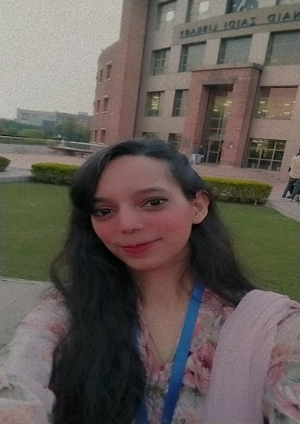
Curriculum vitae

Name: Aqsa Siddique

Residential Address: House # ZB-1167, Street # 02, Model Colony Dhoke Hassu Near Uc 05 Office, Rawalpindi, Pakistan

Mobile: 03475273755 / 0302-8975589

Email: aqsak1446@gmail.com

OBJECTIVE: To obtain an MS Degree in English where my creative ideas and genuine enthusiasm would allow me to progress and enable me to utilize my strong organizational skills, educational background, and ability to work well with people in a career that is fast-paced and rewarding. I possess excellent verbal and written communication skills and am able to work in a multicultural environment. To encourage creativity and higher-order thinking in a way that increases student performance.

PERSONAL DATA
Gender: Female
D.O.B: 29-Jan-1999
Nationality: Pakistani
Marital Status: Single

ACADEMIC ACHIEVEMENT:

2023 - Conti... MS English (Hybrid) 4th Semester
Course Work: 3.46/4.0
Research Work: In Process
COMSATS University, Islamabad
2017 to 2021 BS Bridging (English)
Percentage: 88.50
Obtained CGPA: - 3.54/4.0
Punjab University (Affiliated College Government Viqar Un Nisa College)

2015 to 2017 F.SC (Pre-Medical)
Division: -1st
Obtained marks: - 779/1100
Government Degree College Rawalpindi
2013 to 2015 Matriculation (Science)
Division: - 1st
Obtained Marks: - 924/1100
Government Girls High School Dhoke Hassu Rawalpindi

EXPERIENCE:
- Worked as Customer Service Representative (CSR) at WORK (https://lte.netlify.app/)
- 2 years of experience as a Social Media Marketer (SMM)
- Working as a YouTuber on an Educational Channel (https://www.youtube.com/c/PeakyKnowledge)
- My Steps School and College from July 2024 to August 20204.

COMPUTER SKILLS:
- command on Origin, MS Office
- well-versed in the use of the internet
- own a YouTube channel (@peakyknowledge)
PERSONAL ABILITIES & SKILLS:
- reliable and responsible
- innovative and able to develop new ideas
- convincing skills with a logical mind
- strongly committed to the assigned task

