CURRICULUM VITAE

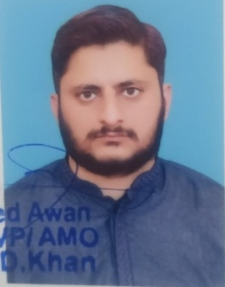
KASHIF NAVEED
Operation Officer, ZTBL
37405-2521502-1
Date of Birth
16.11.1985
Contact No. 0330-2737350
EDUCATION
DEGREE | INSTITUTION | YEAR | MARKS | %AGE
MBA (Finance) | Federal Urdu University, Islamabad | 2009 | 3.69/4.00 | 92%
BSc. (Bot, Zoo, Chem) | Federal Board (ICB, G-6/3), Islamabad | 2006 | 466/800 | 58%
FSc. Pre-Medical | Federal Board (ICB, G-6/3), Islamabad | 2004 | 746/1100 | 68%
Matric (Science) | GCHS, Rawalpindi Board | 2002 | 661/850 | 78%
EXPERIENCE
- Joined ZTBL Layyah Branch (Muzaffargarh Zone) in May 2008 as Management Trainee Officer as Officer Grade-III. Also worked as Mobile Credit Officer for a year.
- Joined ZTBL Gujrat Branch (Gujranwala Zone) in Jan 2010 as Mobile Credit Officer. Responsible for recovery and providing necessary credit to Agri Borrowers.
- Joined ZTBL Gujar Khan Branch in 2013 and worked in Accounts Section as Manager Operations as a desk officer for almost two years
- Posted to ZTBL Head Office Branch, Zero Point, Islamabad as Manager Operations from 2015-2021. Gained relevant commercial banking experience being working in Hub Branch across the Bank. Dealt with Nift, Western Union, Salaries, Hajj Operations across the Bank.
- Worked as Manager Operations in ZTBL Pind Dadan Khan Branch as Officer Grade-II for three years.
- Now working in ZTBL Model Branch Head Office, Islamabad.
SKILLS
- Typing Speed 60 w.p.m
- Excellent command over Word and Excel, Urdu Typing
- Drafting skills

