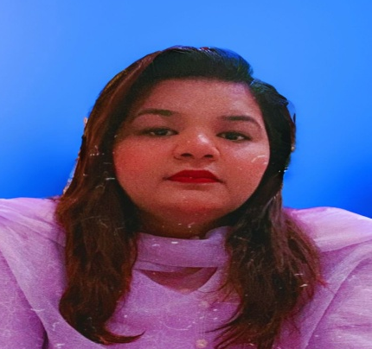

KAINAT GULZAR
Father Name: Gulzar Masih Religion: Christianity
DOB: 01-02-1996
Contact No: +92329-1691240
E-mail: kainatgulzar53@gmail.com
Address: House no.32 block B cantt view-Sargodha

OBJECTIVE

To work with a passionate and motivated team of professionals, seeking goals for future and to apply professional and academic knowledge towards the growth and development of a dynamic organization, which offers challenging opportunities and appreciates the performance. Always engaged in continuous learning in order to broaden my knowledge and experience. Confident, passionate, and enthusiastic about working. Works on the principle of client centered approach that can only have focus on client’s issue physical, social and environmental factors effecting a person’s mental health. Involve in social work activities.

EXPERIENCE

- 1- Year experiences as a clinical psychologist at Bhatti hospital Sargodha.
- 2-year experience of clinical setup, team leading and management of organization at city therapeutic center Sargodha.
- 3-months Internship done with Mind healing services of Pakistan.
- 3-years’ Experience of dealing with psychological patients
- 6-Month internship done at Ashraf Medical Complex Sargodha Punjab Pakistan.
- 8-months working with a private NGO Crime Victim Service of Pakistan.
- Currently working as a clinical psychologist at aman dental and aesthetic clinic Sargodha.

- Affiliated member of APA American psychological association, international society of substance use ISSUP, Australian & New-Zeeland Mental Health Associatio\

ACADEMICRECORD

MS Clinical Psychology University of Lahore Session (2021-2023)  1ST Division | Diploma in pharma tech  Hamza group of college Sargodha
BS hons in Applied Pschology  Riphah international University Lahore  Session (2021-2016)  1st Division | FSC Pre-Medical  Punjab group of college Sargodha  Session (2015)  2nd Division
Matric
Presentation convent high school Sargodha
Session (2012)
1st Division

SKILLS & EXPERTISE

EXPERTISE

- Able to Assess, Diagnose, and Treat Psychological Disorders appropriately
- Able to help people with problems ranging from acute to chronic.
- Able to use Multi-dimensional approach to treat the Client
- Expert in using Psychometrics to diagnose the problem more accurately counseling
- Psychotherapy (CBT REBT, DBT) Preferable command on assessment and therapeutic interventions
- Effective skills in Positive psychology
- Good counselling skills
- Music therapy
- Career counselling
- Art therapy
- Counselling through Islamic perspective
- Family therapy
- Group counselling, Couple counselling, CCT client centered approach
- Drug addiction
- Pharmeco-therapy

SKILLS
- Ability to relate to and empathize with a range of people
- Excellent Verbal & Writing Communication Skills
- Sensitive listening and questioning skill
- Ability to Learn Things Quickly
- Ability to work both on your own and with others
- Ability to cope with emotionally demanding situations
- Expertise with IBM SPSS
- Expertise in MS, Microsoft Exel.

RESEARCH WORK

- Locus of Control, Motivation & Academic Procrastination Among Thesis Students
- BURDEN OF A CAREGIVER OF MENTALLY ILL AND PSCHOTIC FAMILY MEMBER. Understanding the burden and problems that a caregiver faces in caring for a family member with bizarre thoughts and out of touch with the real world.
- Learned helplessness in domestic violence victim
- Psychological immunity and circadian rhythms. “Resilience of the Immune System in Healthy Young Students to 30-Hour Sleep Deprivation with Psychological Stress”
- Relationships between Dispositional Mindfulness, Self-Acceptance, Perceived Stress, and Psychological Symptoms in Advanced Gastrointestinal Cancer Patients
- Social psychology and history Organizational psychology, Peace and conflict study(social project)
- 5-clinical case report writings each include 10-15 individual cases regarding psychological and social issues.
- Internet Addiction And Academic Procrastination In University Students
- Effect of sleep deprivation and psychological stress on immunity.
- Development Adults Sleep deprivation scale.
- Psychological distortion, eupepsia and quality of life in weed consuming addicts during covid- 19.
- Effects of amphetamine on eating and sleeping patterns among young adults of Pakistan.

SAMINARS

  - Music therapy at Superior University Sargodha campus.
  - Internet addiction and sleep deprivation at Roots Millennium School Sargodha.
PAPER PRESENTATION

- Impact of Post Covid-19 on Psychological Distress: Moderating Role of OCD Symptoms among Nurses

SAMINARS

  - Music therapy at Superior University Sargodha campus.
  - Internet addiction and sleep deprivation at Roots Millennium School Sargodha.

PUBLICATIONS

- Impact of Post Covid-19 on Psychological Distress: Moderating Role of OCD Symptoms among Nurses.

REFERENCES

References will be provided on request.

