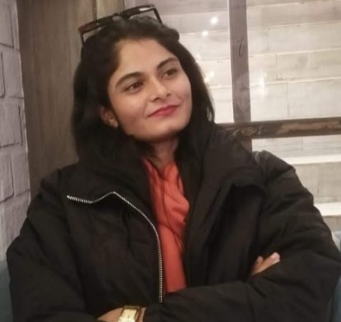
KINZA ANWAAR
(Dietitian/ Nutritionist)

EXPERIENCES
24 April, 2024 – 03 May, 2024
Tehsil Head Quarter Hospital (THQ), Fort Abbas
Worked with other doctors and learnt different cases and make diet
Plans according to the condition.
15 May, 2023 – 30 June, 2023
Department of Nutrition, Pak Healthcare NGO
Worked as a social worker and assessed the rate of malnutrition in
defined areas.

ABOUT
To acquire productive work experience in the practical field and to be part of good environment, that makes effective use of my potential and make my contribution towards achievement of organization’s goals.




Contact
0321-1710072
Kinzad049@gmail.com
Fort Abbas, Bahawalnagar
Education
- 2020-2024
The Islamia University of BWP
BS (Human Nutrition & Dietetics)
CGPA: 3.48/4
- 2017-2019
Bise Bahawalpur
Intermediate (pre-medical)
Marks: 829/1100 (75%)

1
Skills
- Innovative
- Leadership
- Diet planning
- Active listener
- Service-focused
- Graphic designing
- Good communication

PUBLICATION
Ayesha, A., Choudhary, A., Ghaffar, M., Liaqat, N., Anwaar, K., (2024)
“NUTRITIONAL PROFILING OF ANTIOXIDANTS IN WHEAT GRAIN”,
Scientific Research Timelines Journal, 1(1), pp. 12–14.
PROJECT
Assessment of malnutrition in district Bahawalpur using WHO protocols
and STRONG kid tools (under-review).

CONFERENCES & SEMINARS
One Day School Nutrition Assessment & Awareness Camp organized
by HND, IUB at Roots IVY School, Bahawalpur.
Seminar on PCOS awareness (Nov, 2023) organized by WHC&MH and
HND, IUB at The Islamia University of Bahawalpur.
Seminar on Universal Health Coverage Day, 2023 – organized by HND,
IUB and Medical Laboratory Technology, IUB at The Islamia University
of Bahawalpur.
Seminar on Awareness of Nutritional Needs in Emergency (Sep, 2022)
– organized by HND, IUB in collaboration with Punjab Food Authority,
BWP at IUB.
3rd All Pakistan Nutritionists Convention 2021 – Organized by NDS,
Pakistan and HND, IUB at The Islamia University of Bahawalpur.

Membership
Nutritionists and Dietitians Society (NDS), Pakistan

Languages
- English
- Urdu
References will be provided on demand.

