Arooj Ilyas Bhatti
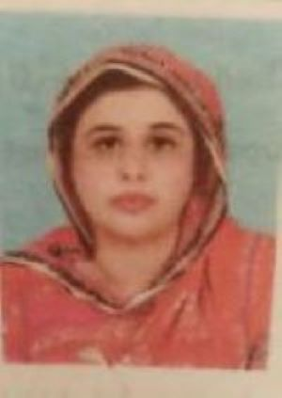
Objectives
I want to work for an organization where I am given a chance to accomplish my tasks successfully by using my skills appropriately.

Education
M.Phil Psychology, Preston University, Islamabad. (3.5 GPA)
M.Sc Applied Psychology, Foundation University, Islamabad (3.5 GPA, Merit Certificate in University)
Bachelors in Arts, Punjab University, Lahore (1st Position in Humanities Group in College, Roll of Honor, Subject Prize in Applied Psychology, Editor, English Section of College Magazine, F.G College for Women, G-10/4, Islamabad)
Intermediate in Arts, Federal Board (Merit Scholarship in Federal Board- Secured 25th position in Humanities Group in FBISE, 1ST Position in Humanities Group in College, Subject Prize for Applied Psychology, Subject Prize for Literature, Subject Prize for Sociology, F.G. College for Women, G-10/4, Islamabad)
Matriculation in Science, Federal Board (Secured 3rd position in School, F.G. Public Secondary School, Morgah, Rawalpindi)

Workshops & Training
- Attended “Power of Gratitude” workshop at Qasim Ali Shah Foundation, Lahore, 15th June, 2019.
- Certification in Hypnosis & Hypnotherapy, Spiritual Psychology, July, 2019

Personal Information
- Email: iarooj873@gmail.com
- Contact: 0301-5623591/ 0333-5610516

