Syed Shafqat Ali
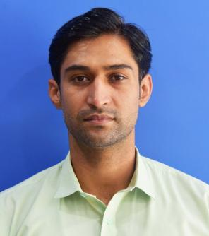
FATHER NAME: Syed Zakir Hussain Bukhari
Contact No: +923467796775
+923100867972
Email: naqvi 77965@gmail.com
CINC: 37405-5620197-1
DATE OF BIRTH: May 01, 1988
Permanent Add: House no ZB 1961, Street no 21, Fouji
Colony,Pirwadhai Rawalpindi

CAREER OBJECTIVE:
To achieve excellence through hard work and commitment to my duties, looking for an organization that provides me a professional environment where I can polish and prove my skills.

EDUCATIONAL QUALIFICATION:
ACADEMIC QUALIFICATIONS:
B.Com 2016
B.com From AIOU Islamabad)
FS.c (DAE) 2009
Punjab Technical Lahore Board
SSC (Science) 2005
B.I.S.E. Rawalpindi Board
OTHER QUALIFICATION

Computer Knowledge:

- MS Office
- Power Point, Word & Excel
- Windows Installation
- Computer Hardware & Software
- Web Surfing
- Awareness of Social Networks

Experience:
- Fast National University Islamabad As a Admin Asst from 17 May 2024 to Still work
- Foundation University secretariat As a Office Assistant in Registrar Deptt (Academic) From Nov 2019 to May 2024
- Foundation University secretariat As a Acting / PA to Registrar From 2020 to May 2024
- Institute of Cost and Management Accountants of Pakistan from 2009 to 2013 as a electrician technician/ computer Operator

LANGUAGES KNOWN:
- English
- Urdu
SKILLS:
- I can adapt quickly to new circumstances and working conditions and able to integrate and work with teams and have repute to meet targets well within time.
- High Level of integrity, trustworthy, hard working, honesty and loyalty
- Receptive to work & time pressure, great team player, positive attitude
- Proposal Writing, report writing & minutes
- Ability to handle multi-dimensional task
- Excellent Communication Skills

Reference: Will be furnished on demand.

