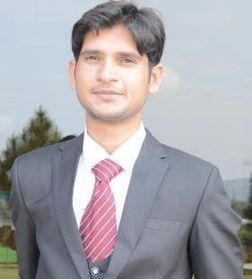

TANVEER NASIR
PhD Media Studies-In Progress
Communication Officer
(Gold Medalist)


PROFILE: Talented & immensely creative journalist With commitment to High-quality research, teaching and Writing. Proven history of achievements in academia & Industry. Experienced in teaching, research and Communication across a variety of platforms including Radio & Online social media.
EDUCATION
University, Islamabad in Progress…
Matric at PPHS 77%
Pre-Medical, Grade: A, 77%,
F.SC at SCA Karak
80%
Grade: A,
CGPA: 3.75,
Islamabad, Pakistan.
Science & Technology,
National University of
Communication at NUST-
MPhil in Mass
PhD Media Studies- Bahria

BASIC INFORMATION:

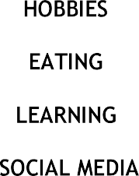

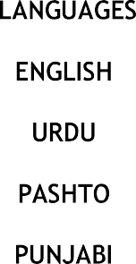
Name: TANVEER NASIR FATHER NAME: KHAN WAZIR CNIC: 14202-7499563-3
Skills

Research Skills Teaching Skills
Reporting Skills Production Skills Management Skills Coordination Skills Media Skills
PASSPORT: JX9825631

D.O.B: 20/12/1998 NATIONALITY: PAKISTANI DOMICILE: KP
RELIGION: ISLAM
Experience:
BS (Hons) in Communication &
Media Studies at Khushal khan
Khattak University Karak, Karak
CGPA: 3.86,
Grade: A,
82%

- Communication & Admission Officer-UOR
- Visiting Lecturer Rawalpindi Women University.
- Teaching Assistant at Bahria University.
- Campus Radio FM 98.6

ISPR ARMY (GHQ)
Social Media Links
LinkdIn: Tanveer Nasir Khattak Twitter: Tanveer Nasir PhD Insta: Tanveer Nasir Khattak Facebook: Tanveer Nasir Khattak Snapchat: tanveer_phd
Wechat: @TanveerNasirKtk
- National Youth Assembly (MNYA)

Achievements:
- Gold Medalist in BS (Hons).
- Silver Medalist in MS.
Matriculation/SSC at PPHS Karak
Grade: A, 1ST Division, 77.81%, |  | Duration:
Apr, 2013 - Jun, 2015

- Merit Scholarship from 1st to 8th Semester in BS.
- Fully funded Tuition Fee Scholarship for MS at NUST

Research Publications:
  - Influence of Social Media Regarding Academic Performance of Students Volume 5(1)2024 Journal of Peace…
Professional Education
ADE 2 Years at AIOU I slamabad.
CGPA: 3.00, Grade: B, 1st Division, 69%.
DIT from TTB Peshawar.
1080/1400
Grade: A, 1st Division, 77.14%.
B.Ed. 4 Years (Equivalent to M.Ed.)
  - Persuasion through Memes, The Evolution of One-China Nation
ICA- Conference Paper in China Volume(1) 2024
  - Influence of Social Media on Narrative Building & Policy Development In Pakistan Journal of Contemporary Social Sciences & Humanities Submitted Will be Published Soon and many more in the pipeline
Workshops/Seminars:
1) Media training and research center Feb, 2020 Training workshop on Media & information literacy
2) Bargad organization for youth development. Youth leadership workshop on campuses.
3 Months Certifications from VU
4) Video Editing, Animation & Vlogging. 92
WORK PORTFOLIO: Will be provided on Demand.

REFERENCES:
1) Communication Skills | 88%
2) Digital Marketing. | 85%
3) Graphic Designing. | 90%

- Dr. UMAR, HOD Mass Communication at NUST, +923336263633
- Dr. ABDUL RAUF, HOD MEDIA DEPARTMENT, KKKUK, +92 333 9339881
REUTERS META COURSE
INTRODUCTION TO DIGITAL JOURNALISM

