OBJECTIVE

Seeking full time opportunity to obtain a challenging position that allows me to utilize my current skills to assist in advancing a business that offers a stable employment opportunity. I am also eager to learn business skills and new technological advancements. Diverse internships (healthcare, telecom, and media) honed technical and interpersonal skills.

EDUCATION PROFESSIONAL EXPERIENCE

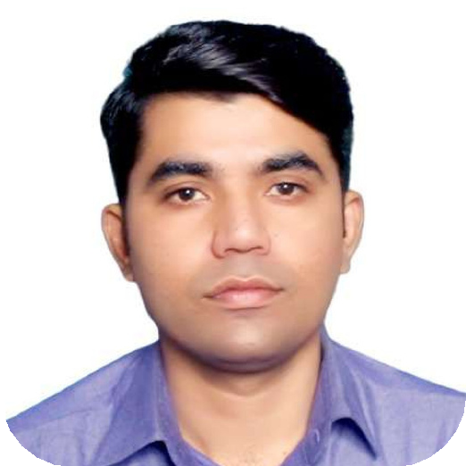BS Hons (Electronics)
MUHAMMAD WAQAS
+92-333-5502924
waqasahmedqureshi01@gmail.com waqas_ahmed01@live.com
House # 129, Street # 1, Dheyri Hassanabad ,Rawalpindi
Sarhad University of Science & Information Technology, Islamabad, Pakistan | July 2008 - October 2012

DAE (Electronics)
Rawalpindi Polytechnic Institute, Rawalpindi, Pakistan | May 2008

SSC (Science)
Board of Intermediate and Secondary Education, Rawalpindi, Pakistan

SKILLS

Student enrollment & registration Records management
System administration Data analysis & reporting Budget management Project management
Interpersonal & relationship building
Public speaking & presentations Crisis communication & conflict resolution
Basic IT skills (MS Office Suite, etc.)
Educational technology platforms Biomedical equipment maintenance

Assistant Coordinator & Information Officer | Punjab Group of Colleges | Rawalpindi, Pakistan | September 14, 2006 – Present

Selection, managing and sourcing information resources.

Guidance and provision of relevant information to concerned.

Reporting between units and Head Office.

Admissions guidance and application.

Maintaining office records for inspection/audit purposes. Vendor’s Dealings.

Training and check on functional and line staff.

Entry Test planning.

Academic/ Career Counseling of students.

Coordination & interaction with Head Office & outstation Campuses.

Maintaining and sending different Operational Reports to Head Office.

Leading & training of Functional staff.

Maintaining and implementing policies and procedures.

Assisting with budget and invoice management.

Intern | International Islamic Medical College Railway Hospital | 2018
Provided technical support for biomedical equipment, ensuring optimal functionality and patient care within a medical setting.
Assisted in research projects, contributing data analysis and report preparation to advance medical knowledge and treatment protocols.
Developed strong interpersonal and communication skills through interaction with diverse stakeholders, including doctors, nurses, and patients.

CERTIFICATION PROFESSIONAL EXPERIENCE

Fundamentals of Computing Program at ZIS Computer Academy (3 months)
Gained essential computer literacy in 3 months through ZIS Academy's Fundamentals program.

Freelancing Course at DigiSkills Training (3 months)
Mastered project management, client communication, marketing, and financial planning for successful freelance navigation.

Digital Marketing Specialist at DigiSkills Training (3 months)
Mastered content marketing, SEO, social media, email, and analytics to craft winning digital strategies for business growth.

ACHIEVEMENTS

Streamlined enrollment and registration processes, improving efficiency and reducing errors.
Developed and implemented effective communication channels, fostering a more
Intern | Pakistan Telecommunication Limited (PTCL) | 2017
Gained valuable insights into the telecommunications industry, working within the Transmission Network Division to learn about infrastructure maintenance and network optimization.
Assisted engineers with technical tasks, contributing to the smooth operation and expansion of the telecommunications network.
Developed critical problem-solving and analytical skills through troubleshooting network issues and identifying potential improvements.

Intern | DUNIYA NEWS | 2016
Provided technical support to the DSNG (Digital Satellite News Gathering) team, ensuring efficient news acquisition and transmission from remote locations.
Learned about the technical aspects of news broadcasting and gained valuable experience in a fast-paced media environment.
Developed strong teamwork and communication skills while collaborating with journalists and technical personnel to achieve deadlines.

FINAL YEAR PROJECT
open and informed student

body.
Collaborated effectively with diverse departments to create a positive and supportive learning environment.
PC BASED RADIO FREQUENCY JAMMER
PC-Based Radio Frequency Jammer monitors and controls RF communication in various bands, jamming selected bands based on traffic or user instructions. It produces a noisy signal in the corresponding band, beneficial for security, military, and defense applications.

