Muhammad Fahad Bashir
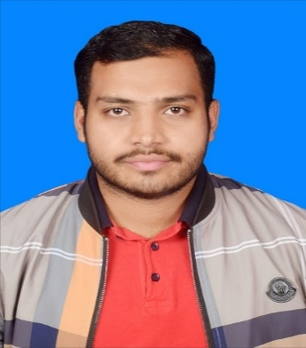
Position: Network IT Support Engineer
Mob No: 03345204108
Address: House No :430, Street No:33 Phase 4-A
Email: fahdim051@gmail.com

Career Objective
Dedicated IT and Support Engineer with a strong passion for delivering exceptional technical assistance and solutions. Adept at diagnosing and resolving complex hardware and software issues, with a keen eye for detail and a systematic problem-solving approach. I am committed to providing reliable support and innovative IT solutions that optimize efficiency and enhance user experiences.
Technical Knowledge
- Cisco Switches – 2950,3650 series.
- Huawei Switches - S-6730, S-5735.
- Huawei Access Points- Air Engine 5761-21.
- Huawei Access Point- Air Engine 6760R-51.
- Sangfor IAS firewall.
- H3C WX2860X Wireless Controller
- H3C S6520 Core Switch
- H3C S5170 Series
- Switching: VLAN, STP.
- Experience supporting desktop/ laptops, software installation, hardware.
- Experience in Printer Configuration.
- Operating Systems: Cisco IOS, Windows.
- I have capability to configure all type of devices and switches.
- Work on Network tools Putty, SecureCrt, mRemoteNG.

EXPERIENCE
- Riphah International University
- IT and Network Support Engineer
- August 2022 to present.

- Designing, implementing, and testing wireless, Local Area Network (LAN), Wide Area Network (WAN), internet.
- Wateen Project Implementation in Riphah International University.
- Install, configure, troubleshoot network devices. Switches, Routers, Sangfor-lAS Firewall
- Wireless devices manage through wireless controller and their configuration.
- Assisting the IT department with various IT-related upgrades, projects, and tasks.
- Daily queries handling staff of Riphah International University Staff and Students.
- Backup of network devices on a monthly basis.
- Providing on-call and TeamViewer technical support for network problems.
- Daily inventory management of RIU.
- Assisted other team members in providing next level Help Desk support.
- Resolving network related issues in a timely manner.

Certifications
- Network Security (Coursera)
- Google IT Support (Coursera)
- Cyber Security (Coursera)

Additional Skills
- Proficient in Microsoft Office o365, and Windows 10.
- Communication skills.
- Problem-solving.
- Time management.
- Teamwork

Academic Qualifications

Year | Degree
In Progress | BSCS (Bachelor of Science in Computer Science)
2022 | Diploma of Associate Engineering (DAE)
2018 | Matriculation (Science)

Personal Information

Date of Birth : 19/02/2002
Gender : Male
Religion : Islam
Nationality : Pakistani
Marital Status : Single
Language : Urdu, English

